Glossary
Term | Definition
Assertion | A check that verifies whether the actual result matches the expected result.
Fixture | Reusable test setup or data provided to a test.
Parameterization | Running the same test with different input values.
Marker | A label used to categorize or select Pytest tests.
Allure Report | A visual test report generated from test execution results.

Technical Learning Report: Day 2
Date: October 1, 2026
Intern Name: Shekhar Singh Rawal
Subject: Pytest Unit Testing and Allure Report Generation

1. Objective
The objective of Day 2 was to learn Pytest as a Python testing framework and use it to create automated tests for a user data and purchasing module. The work focused on assertions, parameterization, fixtures, markers and generating test reports using Pytest-Allure. The practical exercise involved testing user information, balance, purchased items, stock data, total calculation, and sufficient-balance logic for userId = 1 and user Shekhar Rawal.

2. Technical Breakdown

2.1 Pytest
Pytest is a Python testing framework used to write and execute automated tests.
It allows test functions to be created using the test_ naming convention.

3. User Data Used for Testing
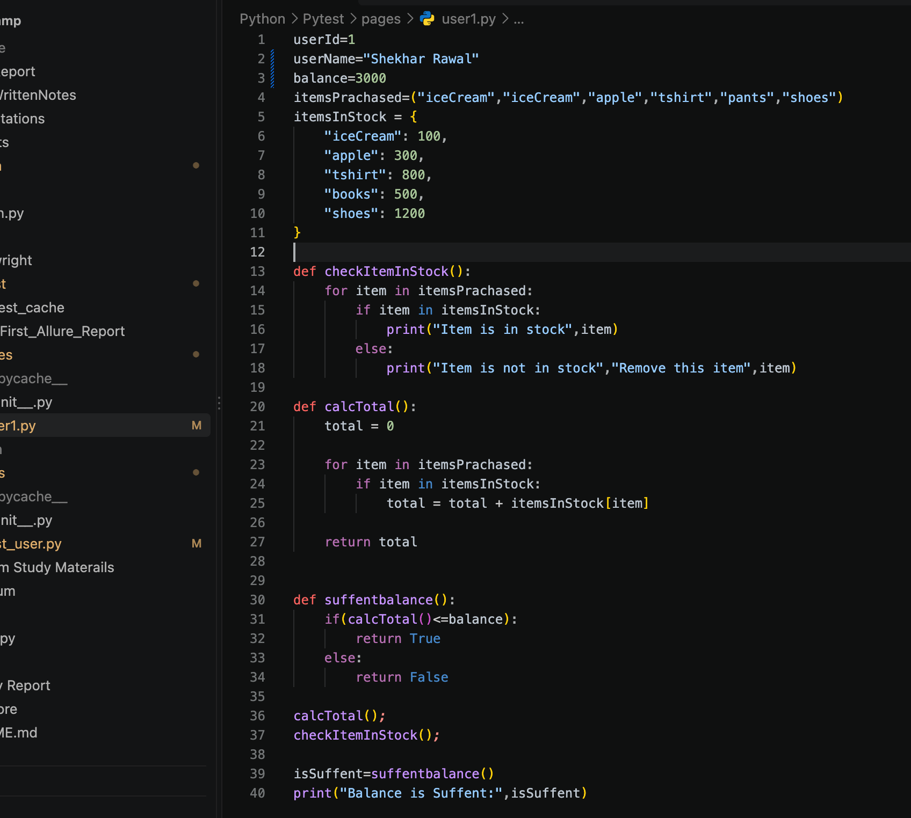
Output For user1
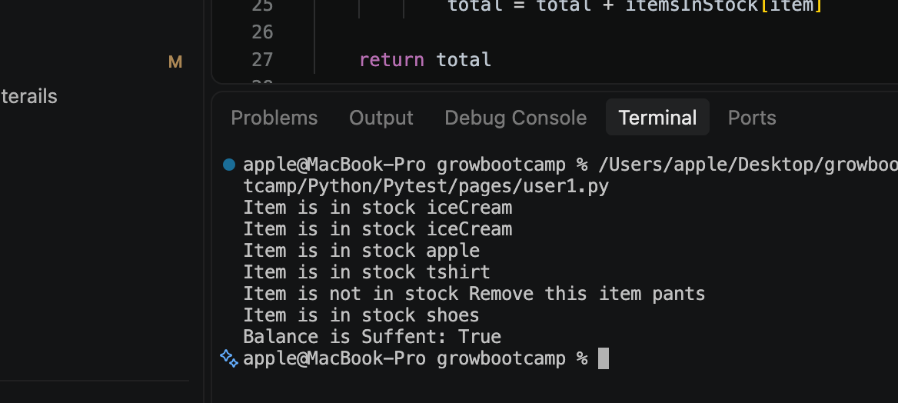

4. Functions Under Test

4.1 checkItemInStock()
This function checks every purchased item against the available stock.
def checkItemInStock():
for item in itemsPrachased:
if item in itemsInStock:
print("Item is in stock", item)
else:
print("Item is not in stock", "Remove this item", item)
The function identifies whether each purchased item exists in the stock dictionary.
For example:
Purchased Item | Present in Stock?
iceCream | Yes
apple | Yes
tshirt | Yes
pants | No
shoes | Yes

4.2 calcTotal()
The function calculates the total price of purchased items that are present in the stock list.
def calcTotal():
total = 0
for item in itemsPrachased:
if item in itemsInStock:
total = total + itemsInStock[item]
return total
The function loops through the purchased items and adds their corresponding prices.
The two iceCream entries are both included in the calculation because they appear twice in the purchased-items tuple.

4.3 suffentbalance()
This function checks whether the calculated purchase total is within the available balance.
def suffentbalance():
if calcTotal() <= balance:
return True
else:
return False
The result is a Boolean value:
True → Sufficient balance
False → Insufficient balance

5. Assertions
An assertion checks whether the actual result matches the expected result.
The practical tests used assertions to validate different properties of the user data.
Examples
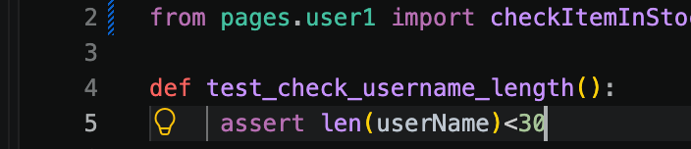

Assertions Practiced
Test | What It Checks
test_check_username_length | Username length
test_check_username_Invaild_Chr | Invalid characters
test_check_balance | Balance data type
test_item_prachased_type | Purchased items are a tuple
test_item_prachased_itemsType | Tuple items are strings
test_item_in_stock | Stock data is a dictionary
test_total_cal | Total calculation returns a result
test_suffesent_balance | Sufficient-balance result
Assertions therefore convert expected behavior into automatically verifiable checks.

6. Parameterization
Parameterization allows the same test to run multiple times with different input values.
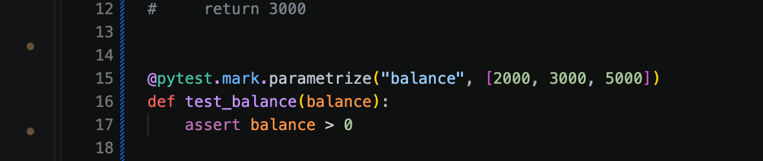
Instead of creating three separate tests, Pytest executes the same test with:
Test Run | Balance | Expected
1 | 2000 | Greater than 0
2 | 3000 | Greater than 0
3 | 5000 | Greater than 0

QA Benefit
Parameterization reduces duplicate test code and makes it easier to test the same rule with multiple inputs.

7. Fixtures
A fixture provides test data or setup that tests can use.
A fixture example was considered in the code:
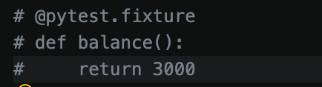
The fixture was commented out in the provided implementation, so it was not used as an active fixture in the final tests.
The concept was covered as part of the Pytest learning.

Purpose of Fixtures
Fixtures can be used for:
- Test data
- Initial setup
- Reusable objects
- Common preconditions
- Cleanup activities

8. Markers
Markers are labels that can be assigned to Pytest tests to organize or select specific groups of tests.
The practical work included the parameterization marker:
@pytest.mark.parametrize
This marker provides multiple values to the same test.
The broader concept of custom markers was also covered as part of Pytest features.
For example, teams can conceptually organize tests into categories such as:
Smoke
Regression
Integration
Unit
Markers make it easier to select particular groups during test execution.
Pytest Result:
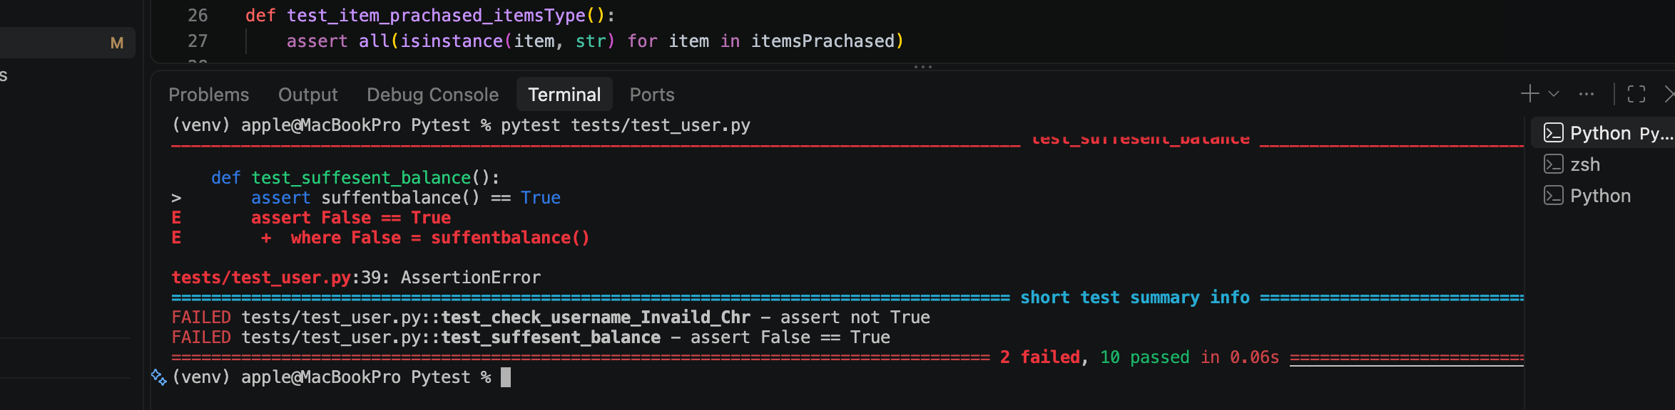

10. Allure Report Generation
The practical objective was to generate an Allure report for the Pytest tests.
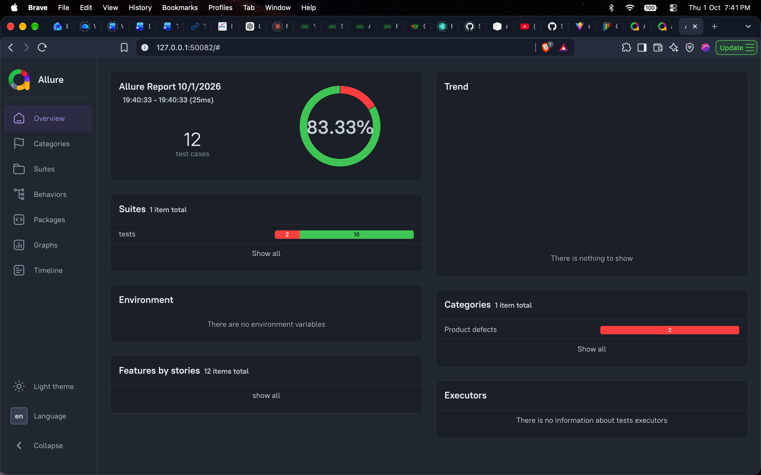

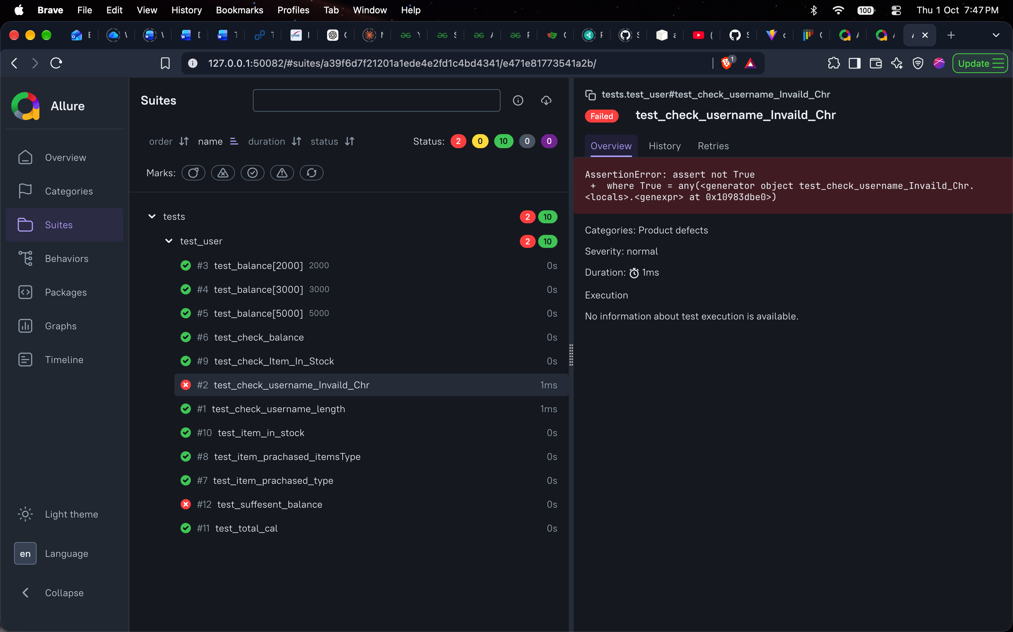The test suite contained checks for:
- Username
- Username characters
- Balance
- Purchased-item type
- Purchased-item values
- Stock data
- Item availability
- Total calculation
- Sufficient balance

11. Practical Test Suite
The implemented Pytest test suite included the following tests:
Area | Validation
User | Username length and characters
Balance | Data type and different balance values
Purchased items | Tuple and string validation
Stock | Dictionary validation
Stock checking | Purchased items checked against stock
Calculation | Purchase total calculation
Business rule | Sufficient balance

14. Key Findings & Best Practices
- Pytest provides a simple structure for writing Python automated tests.
- Assertions verify whether actual results match expected conditions.
- Parameterization allows one test to run against multiple input values.
- Fixtures can provide reusable test data and setup.
- Markers help organize and select groups of tests.
- Plugins extend Pytest with additional functionality.
- Allure provides a structured way to visualize Pytest execution results.
- Tests should validate both data properties and relevant business rules.
- Reusable test data and parameterization can reduce duplicate test code.
- AI-generated automation code should be reviewed and understood before being used.

15. Conclusion
Day 2 of Week 5 focused on Pytest-based automated testing and test reporting using Allure. A user purchasing module was used to practice assertions, parameterization, data validation, stock checking, total calculation, and sufficient-balance validation. Pytest concepts including fixtures, markers, and plugins were also studied. Allure reporting demonstrated how automated test execution can be converted into a structured report that makes test results easier to review and monitor.

